**RTP site new functions**  
  
Function 1  
New Pola function

+ Refer image 1 for layout  
+ remain the old pola function

+ Range : 10 -100 (values by tenth : 10, 20, 30, 40)  
+ if wording is too cramp, add a row above games to explain the emojis (Refer image 2)  
  
Image 1  
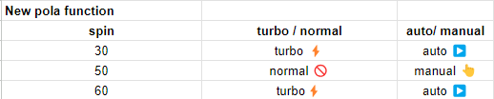  
  
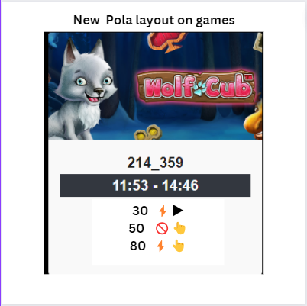

Image 2  
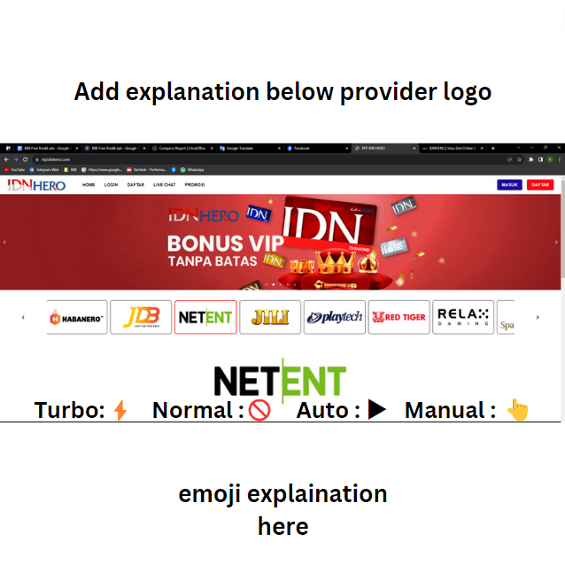

Function 2  
+ Able to show or hide pola functions without affecting jam gacor & percentage (Refer image 3)  
  
Image 3  
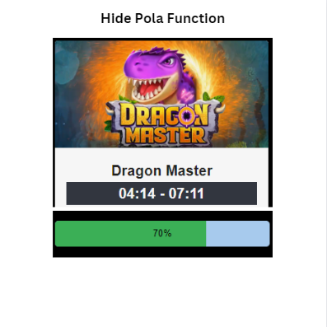

Function 3  
+ Able to hide provider without deleting